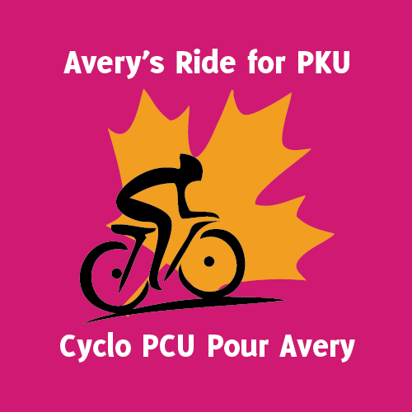
Please join the Compeau Family on Monday July 28th 2014, between 4pm-7pm for a BBQ and gathering at their home in Kingston, ON, as we welcome Mr. Kevin Dube into the City of Kingston. Both of our sons have classical PKU and we want to show our support for this amazing fundraising initiative!!!!!
About PKU:
PKU is short for phenylketonuria (pronounced fen’-il-kee’-to-nu’-ria) and is a rare, inherited metabolic disease that results in mental retardation and other neurological problems when treatment is not started within the first few weeks of life. People with PKU are missing an enzyme to break down protein in food, specifically one amino acid. This amino acid is called phenylalanine, often called PHE (pronounced fee). Since this amino acid cannot be completely processed, it builds up in the blood and excess amounts cross the blood-brain barrier. When excess amounts build up, brain damage and other neurological problems result.
About Avery’s Ride:
Kevin Dube is Avery’s Uncle; Avery is a young girl who has PKU. Kevin and his family have taken on an amazing feat! Kevin is cycling across Canada from June 2014 until August 2014 in an attempt to raise funds and awareness for PKU. Kevin will be in the Kingston area on Monday July 28th 2014, and we would love your support in helping him on his path to meet his fundraising goal; which was initially set at $25,000, however, he has surpassed this and his new goal is $40,000-Let’s help Kevin who has selflessly taken on this task to make life easier with PKU.
Gathering details:
When: Monday July 28th 2014, from 4pm-7pm
Where: Compeau Residence-Bryan, Tanya, Declan and Emmett
What: A gathering to celebrate the accomplishments of Avery’s Ride for PKU, to generate funds and awareness for PKU and to meet other families who understand PKU.
There will be door prizes, a silent auction, t-shirts for sale ($15 minimum donation each), ‘everyone’s a winner’ baked goods sales (similar to 50/50 draw), hot dogs, hamburgers and non-alcoholic beverages available (donations to assist with the overhead for the BBQ is appreciated), and of course great company!!!
Please feel free to bring your empty beer bottles and liquor bottles-we will gladly return them and donate the funds to Avery’s Ride for PKU.
We will have some PKU friendly foods on hand and the amenities available to manage your PKU diet we just ask that you help yourself with this!
Please see the next page for RSVP details, more info about Avery’s Ride and how you can help with this amazing project!
RSVP: tanya.trebley@gmail.com (Tanya)
bryan.compeau@gmail.com (Bryan)
(Please try and RSVP so we have all we need!!!)

Website for Avery’s Ride: http://www.rideforpku.ca/english/
If you can’t make the gathering donations can be made on the website or directly to Bryan or Tanya Compeau!
A special thanks to the Kingston Waterfront Holiday Inn, Fort Henry, Marrello’s Hair Salon, Styles for Miles Hair Salon and King’s Town Massage Therapy for their donations.
If you would like to donate an item for this event please let us know-everything accepted and appreciated!!!!!

ALL OF YOUR SUPPORT IS APPRECIATED!!!!!
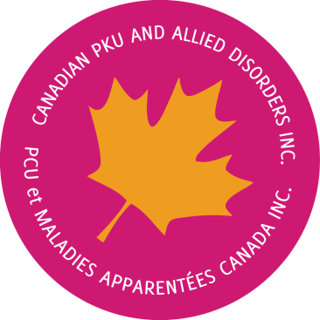
Proceeds from Avery’s Ride for PKU will be used to cover the cost of the ride. Any funds raised in excess of this amount will be used by CanPKU to continue creating awareness, providing education opportunities and advocating for the needs of the Canadian PKU community.

